|  |
| --- |
| CARLETON UNIVERSITY |
| Modeling the effects of Parasitoids on population dynamics of the Diamondback moth using Cell-DEVS |
| SYSC-5104 |
|  |
| **Michael Van Schyndel 100736354** |
| **11/15/2011** |

|  |
| --- |
|  |

Contents

Part I Conceptual Model (Schyndel, 2011) 3

1.0 Introduction 3

1.1 Diamondback Moth 3

1.2 Parasitoids 4

2.0 Cell-DEVS Model 4

2.1 1st Layer - Cabbage 4

2.2 2nd Layer- Egg and Larva 5

2.3 3rd Layer- Pupae 5

2.4 4th-5th Layer - Adult Female DBM and Adult Male DBM respectively 5

2.5 6th-7th Layer- Adult Female Parasitoid and Adult Male Parasitoid respectively 5

Part II Model Specifications and Results 6

3.0 Formal Specifications 6

4.0 Implementation of Rules 6

4.1 Parasitoids M/F and DBM M/F 6

4.2 Egg and Larva 7

4.3 Pupae 8

5.0 Evaluation of the Model 8

5.1 Annihilation of DBM population 8

5.2 Disappearance of Parasitoid Population 9

5.3 Equilibrium 10

6.0 Conclusion 11

Works Cited 12

Equation 1 4

Equation 2 4

Equation 3 8

Figure 1 Theoretical Random Movement 5

Figure 2 Movement Table 6

Figure 3 DBM TEST Legend 8

Figure 4 Test 1 Results 9

Figure 5 Test 2 Results 10

Figure 6 Test 3 Results 11

# Part I Conceptual Model (Van Schyndel, 2011)

## 1.0 Introduction

In the biology community predator-prey relationships are often examined and modeled theoretically using discrete equations to determine population sizes at given times. Normally the parameters for these equations are derived from observations of real environments and shaped to fit the equations so that they may accurately model reality. However, in a paper presented by (Henri E.Z. Tonnanga, 2009), they attempted to model a biological phenomenon using a purely mathematical approach. Using a mathematical approach they generated a list of parameters to pass through the equations. The phenomenon they wished to recreate was that of the effect that introducing a species of parasitoid into the environment would have on the Diomandback moth. The purpose of this was to determine the whether the model could then be used as a means of determining the most efficient course of action to control the Diomandback moth's population.

### 1.1 Diamondback Moth

The Diamondback moth (DBM) is a pest native to Europe that over the past years has migrated until it can now be found worldwide. The larval stage of the DBM destroys leafy crops such as cabbage, lettuce, broccoli, etc. There are pesticides that are used to control the population, however genetic mutations cause the pesticides to become less effective after several generations and require new pesticides to be constantly created. An interesting observation though, is that in Europe the DBM is not a serious threat since its population is kept in check by natural means. That is to say, in Europe, there are approximately 25 species of parasitoids that prey on the DBM and thus act as a population control. The DBM has a 4 stage life cycle that is as follows:

#### 1.1.1 Egg

The DBM will lay eggs on the underside of a plants leaf ranging from groups of 1-3 and take approximately 5-6 days to reach maturity.

#### 1.1.2 Larva

The larval stage can be split into 4 distinct steps that will last for 10-21 days while the larva feed on the plant and grow in size. The length of time till maturity depends mainly on environmental factors such as temperature, food abundance, etc.

#### 1.1.3 Pupae

The pupae stage will last from 5-15 days.

#### 1.1.4 Adulthood

Once they have reached adulthood the DBM will begin reproducing. A female DBM can lay upwards of 1600 eggs during its 16 day lifespan.

The total time it takes a DBM to reach maturity is about 32 days, however new generations will appear 21 to 51 days apart depending on conditions (Agriculture and Agri-Food Canada, 2008).

### 1.2 Parasitoids

The parasitoids that prey in on the DBM vary over several species, however most studies, specifically the study by (Henri E.Z. Tonnanga, 2009) treat them as a single organism. The parasitoid will attack the DBM during the larval stage and will inject its egg inside the host. Upon hatching it will destroy the host and consume it, emerging in adulthood.

## 2.0 Cell-DEVS Model

This model will have the same goals as the paper presented by (Henri E.Z. Tonnanga, 2009). A cellular automata will be created that will attempt to reproduce the interactions between the predator and the prey and will be deemed successful if it can mirror the results that they generated. The first attempt at this model will represent the different entities with the most basic of parameters and thus several assumptions must be made. The equations that were used in the original model are as follows:

Equation

Equation

(Henri E.Z Tonnad, 2009)

The results of these equations with their given parameters can be seen in .

As stated before, for this model several assumptions will be made. There will be 7 unique planes that will be responsible for their own entities with limited interactions with each other and will have a pre determined set of parameters. They are as follows:

### 2.1 1st Layer - Cabbage

In this model the plant, or crop, in question will be assumed as cabbage plants. For the initial model, the cabbage plant will be assumed to have a live span of infinity and will have a fixed density without any reproduction or destruction. Each plant will only allow for a single egg to be laid on it, and only allow for a single reproductive pair to perch upon it, with the assumption made being sexual reproduction occurs on the plant.

### 2.2 2nd Layer- Egg and Larva

The egg will reach maturity after exactly 5 "days" at which time it will reach its larval stage. The larval stage will be represented as a single stage, instead of the 4 sub stages that exist in reality, and will be vulnerable to attack during this period of time. The time it will take to reach maturity will be fixed at 10 days. A larva that is infected with a parasitoid will take 10 days after the time of infection to reach maturity at which point a mature parasitoid will emerge and will be either male or female with the rate of each being 1:1 respectively.

### 2.3 3rd Layer- Pupae

The pupae stage will last for exactly 5 days upon which a mature DBM will emerge. The sexes will be split 50:50 for male and female DBM. Upon reaching maturity the adult will appear in the same location but on the corresponding plane if that location is empty, otherwise it will die. This is representative of an ecosystems maximum support capacity, i.e. if the population is near its maximum fewer offspring will survive or if the population is not near its maximum then the majority of offspring will survive. The assumption is made that the maximum carrying capacity is 100% or 1 occupant per cell. Therefore if the population reaches the capacity, say 85%, then the odds of surviving till maturity is 15%.

### 2.4 4th-5th Layer - Adult Female DBM and Adult Male DBM respectively

The adult male and female DBM will have the same lifespan of 16 "days" and will have the same rules for travel. It will be a random 8 point travel with priority given as seen in figure 1.

|  |  |  |
| --- | --- | --- |
| 7 | 8 | 1 |
| 6 |  | 2 |
| 5 | 4 | 3 |

Figure Theoretical Random Movement

The female will search for an empty plant and upon locating one will stay there until fertilized. To become fertilized male must occupy the same plant as the female for 2 cycles or 1/10th of a day before leaving to find another mate. Upon fertilization the female will leave the plant in search of a empty plant and a new mate.

### 2.5 6th-7th Layer- Adult Female Parasitoid and Adult Male Parasitoid respectively

The parasitoids follow the exact same rules as the DBM with the only exception being, instead of the female searching for an empty plant, the female will search for a plant occupied with larva.

Time will be measured as every 1/200 of a second representing 1 day or inversely 20 cycles representing 1 day, and therefore it is expected that a new generation should appear every 21 days or 420 cycles.

The assumption being made as well as the parameters are being made basic at first to determine the efficacy of cellular automata to model this phenomenon, however there is room to adjust the rules and parameters to become more complex and more able to accurately represent reality.

# Part II Model Specifications and Results

## 3.0 Formal Specifications

DBM(t1,t2,t3,d,pinitialDBM,pinitialParasitoid,pinitialPlant) = <Xlist, Ylist, X, Y, n ,{ t1,t2,t3}, N, C, B, Z, select> (Goldstein, 2007)

Where:

Xlist = Ylist = X = Y = 0 i.e. there are no inputs or outputs

n = 3

t1,t2,t3  are; 100, 100 and 7 respectively

The neighbourhood, is a 5x5 grid an additional 6 neighbours with x and y co-ordinates of (0,0) and the z co-ordinates being 1 through 6.

$N=\text{\{<}i,j,z\text{>}∣\text{(}i∈\text{\{}-2,-1,0,1,2\text{\})}∧\text{(}j∈\text{\{}-2,-1,0,1,2\text{\})}\text{ + <z>|(}z∈\text{\{}1,2,3,4,5,6\text{\}}\text{) }\text{\}}$ (Goldstein, 2007)

The borders are to be wrapped modelling a closed system of infinite length and width.

B = 0

There is no specific transition order for Z.

## 4.0 Implementation of Rules

### 

### 4.1 Parasitoids M/F and DBM M/F

Each cell contains two pieces of information, the direction of the next movement and the age of the cell. How the direction of the cell is stored can be seen in figure2.

|  |  |  |  |  |  |  |  |  |
| --- | --- | --- | --- | --- | --- | --- | --- | --- |
| 1,10,11  No Move | 2 | 3 | 4 | 5 | 6 | 7 | 8 | 9 |

Figure Movement Table

The movement is a two stage process. If the cell is a 1, then the next move hasn't been determined, therefore the following code would be run:

*rule : { (0,0,0) + trunc(uniform(1,9)) + 1/1000 } 1 { trunc( (0,0,0) ) = 1 and (0,0,0) != 0}*

The cell then becomes a random integer between 2-9. Then in the following step the "cell" will move if it is able to otherwise it reverts back to a 1 as follows:

*rule : { (1,0,0) - 1 + 1/1000} 1 { (0,0,0) = 0 and trunc( (1,0,0) ) = 2 }*

*rule : 0 1 { trunc( (0,0,0) ) = 3 and (-1,1,0) = 0 and trunc( (0,1,0) ) != 2 }*

The age of the cell is stored in the decimal position. One complete movement cycle is equal to 1/500 or 0.002. For the purpose of this model one day is equal to 10 complete cycles or 0.02.

As defined in section 2.4 and 2.5, the female will remain still upon finding a empty plant. This is represented by the state 10, and once fertilization has occurred 11. This is performed by the following rules:

*rule : { (0,0,0) + 9 + 1/1000 } 1 { trunc((0,0,0)) = 1 and trunc((0,0,-4)) = 1 }*

*rule : { (0,0,0) + 1/1000 } 1 { trunc((0,0,0)) = 10 and trunc((0,0,-1)) != 11}*

*rule : { (0,0,0) + 1 + 1/1000 } 1 { trunc((0,0,0)) = 10 and trunc((0,0,-1)) = 11}*

*rule : { (0,0,0) - trunc(uniform(1,9)) + 1/1000 } 1 { trunc((0,0,0)) = 11 }*

A similar approach is taken with the males, with the difference being that it searches for an available female. This is done with the following code:

*rule : { (0,0,0) + 9 + 1/1000 } 1 { trunc((0,0,0)) = 1 and trunc((0,0,-6)) = 10 }*

*rule : { (0,0,0) + 1 + 1/1000 } 1 { trunc((0,0,0)) = 10 }*

*rule : { (0,0,0) - 10 + 1/1000 } 1 { trunc((0,0,0)) = 11 }*

Finally, upon reaching a count of 0.32 the cell will die:

*rule : 0 1 { remainder((0,0,0),1) > 0.32 }*

### 4.2 Egg and Larva

There are 7 main states on this plane and are as follows:

20 <- Egg 21<-Larva 22<-Mature Larva 60<-Larva Infected with Parasitoid 61<-Mature Parasitoid 62<- Male Parasitoid 62<- Female Parasitoid

The age of the cell is determined by increasing the value of the cell by the following calculation:

Equation

For example, if it takes 5 days to reach maturity then the cell would have 1/100 added to it for each iteration.

Once the larva reaches maturity it will move to the pupae plane. The code for all this is can be seen in the appendix.

### 4.3 Pupae

The pupae plane operates similar to the Egg and Larva plane. The pupae is represented by an 80 and a mature pupae an 81. The difference however, is that upon reaching maturity, 81, the pupae then becomes a 82 or and 83 at a ratio of 1:1. This represent either a male or female DBM being born.

## 5.0 Evaluation of the Model

This model is meant to have the parameters adjusted to accurately model different biological events, therefore three different scenarios where tested; annihilation of DBM population, disappearance of parasitoids, equilibrium.

### 5.1 Annihilation of DBM population

If the initial population of the released parasitoids is too high or they are too effective of predators they may destroy the population of DBM. This is a undesirable result since any reappearance of the DBM population would be allowed to grow uncontrollably since the parasitoid population would have died of as well since it is not a native species. That is why this model is important so that the proper parameters can be determined. In this test a population density of DBM was set to be 50%, the density of parasitoids was set to 10% and the density of plants was 90%. The results were as follows:

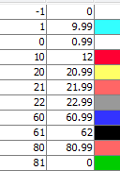

Figure DBM TEST Legend

t= 00:00:00:075

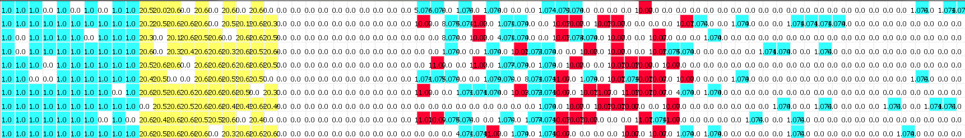

t= 00:00:00:150

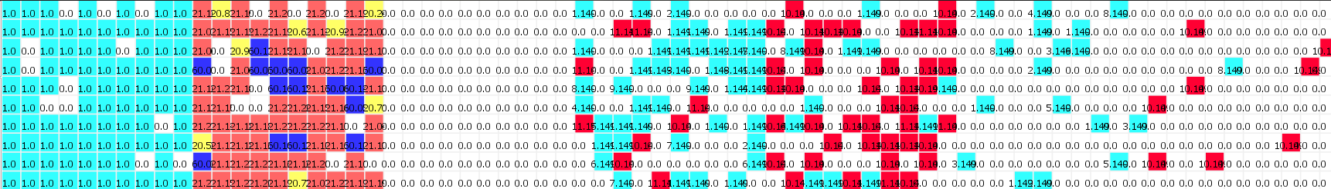

t= 00:00:00:550 (approximately 1.5 Generations)

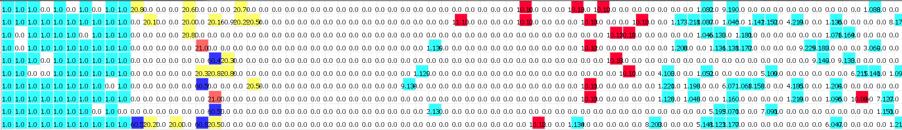

t= 00:00:01:000 (approximately 3 Generations)

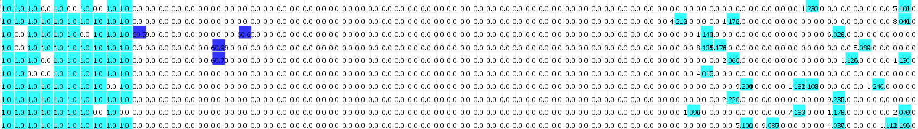Figure Test 1 Results

As you can see the large initial population of parasitoids allowed them to overrun the DBM population and resulted in their complete destruction.

### 5.2 Disappearance of Parasitoid Population

The following are the results for when the initial density of parasitoids was 2%:

t= 00:00:00:003



t= 00:00:00:100



t= 00:00:00:300 (approximately 1 Generations)



t= 00:00:01:000 (approximately 3 Generations)

Figure Test 2 Results

### 5.3 Equilibrium

For the following test the initial condition where kept the same except the parasitoid population density was changed to be 3%. The results where the following:

t= 00:00:00:100



t= 00:00:00:500 (approximately 1.5 Generations)



t= 00:00:01:000 (approximately 3 Generations)



t= 00:00:01:200 (approximately 4 Generations)

Figure Test 3 Results

The results show that the parasitoids managed to maintain a relative equilibrium for a notable length of time. This supports the idea that released parasitoids may be able to have a controlled effect on the population sizes of DBM.

## 6.0 Conclusion

Overall, the model demonstrates that it is possible to model a biological event such as DBM populations as well as how it would be possible to extrapolate information from the model to apply to a real world scenario.

# Works Cited

Agriculture and Agri-Food Canada. (2008). *Diamondback Moth.* Retrieved 11 14, 2011, from Government of Saskatchewan: http://www.agriculture.gov.sk.ca/Default.aspx?DN=688b2f99-ad99-423d-900c-c01a1c45d8a1

Goldstein, R. (2007). *Tumor-Immune System.*

Henri E.Z Tonnad, L. V. (2009). Assessing the impact of biological control of Plutella xylostella through the application of Lotka–Volterra model. *ecological modelling 2 2 0* , 60-70.

Henri E.Z. Tonnanga, c. ,. (2009). Assessing the impact of biological control of Plutella xylostella through the application of Lotka–Volterra model. *ecological modelling* , 60-70.

Van Schyndel, M. (2011). *Using Lotka-Volterra Equations to model the impact of parasitoids on the Diamonback moth.*